[Thực hành] Quản lý User sử dụng JSP-Servlet-JDBC-MySQL

Mục tiêu
Luyện tập sử dụng JDBC

Mô tả
Xây dựng ứng dụng WEB quản lý User bao gồm các chức năng sau:
- Hiển thị danh sách User
- Thêm mới User
- Sửa thông tin User
- Xoá User
Thực hành các thao tác CRUD.

Hướng dẫn
Bước 1:Tạo mới dự án.
File -> New ->Project ->Gradle
Đặt tên dự án user-manager và chọn vị trí lưu dự án.
Tạo cấu trúc dự án như sau:
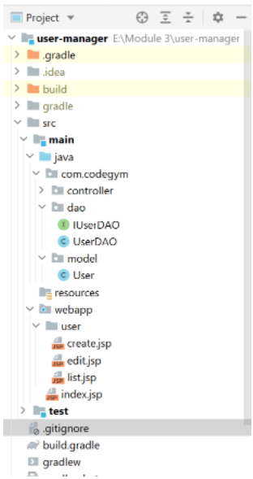
Trong file build.gradle thêm các thư viện như sau:
dependencies {
compileOnly group: 'javax.servlet', name: 'javax.servlet-api', version: '4.0.1'
implementation group: 'javax.servlet', name: 'jstl', version: '1.2'
implementation group: 'mysql', name: 'mysql-connector-java', version: '8.0.23'
}
Bước 2: Tạo cơ sở dữ liệu.
Trong MySQL, tạo cơ sở dữ liệu "demo". Tạo bảng "users" như sau:
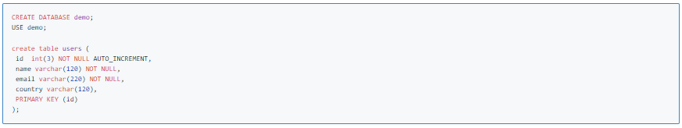
Thêm một số dữ liệu mẫu như sau:
insert into users(name, email, country) values('Minh','minh@codegym.vn','Viet Nam');
insert into users(name, email, country) values('Kante','kante@che.uk','Kenia');
Bước 3: Tạo model.
Trong thư mục "model", bạn tạo class "User" như sau:
package com.codegym.model;
public class User {
protected int id;
protected String name;
protected String email;
protected String country;
public User() {}
public User(String name, String email, String country) {
super();
this.name = name;
this.email = email;
this.country = country;
}
public User(int id, String name, String email, String country) {
super();
this.id = id;
this.name = name;
this.email = email;
this.country = country;
}
public int getId() {
return id;
}
public void setId(int id) {
this.id = id;
}
public String getName() {
return name;
}
public void setName(String name) {
this.name = name;
}
public String getEmail() {
return email;
}
public void setEmail(String email) {
this.email = email;
}
public String getCountry() {
return country;
}
public void setCountry(String country) {
this.country = country;
}
}
Bước 4: Tạo interface IUserDAO:
package com.codegym.dao;
import com.codegym.model.User;
import java.sql.SQLException;
import java.util.List;
public interface IUserDAO {
public void insertUser(User user) throws SQLException;
public User selectUser(int id);
public List<User> selectAllUsers();
public boolean deleteUser(int id) throws SQLException;
public boolean updateUser(User user) throws SQLException;
}
Bước 5: Tạo lớp truy cập cơ sở dữ liệu:
Tạo lớp UserDAO cho phép người dùng thao tác với dữ liệu (Tạo mới, đọc, cập nhật, xoá).
package com.codegym.dao;
import com.codegym.model.User;
import java.sql.Connection;
import java.sql.DriverManager;
import java.sql.PreparedStatement;
import java.sql.ResultSet;
import java.sql.SQLException;
import java.util.ArrayList;
import java.util.List;
public class UserDAO implements IUserDAO{
private String jdbcURL = "jdbc:mysql://localhost:3306/demo?useSSL=false";
private String jdbcUsername = "root";
private String jdbcPassword = "123456";
private static final String INSERT_USERS_SQL = "INSERT INTO users (name, email, country) VALUES (?, ?, ?);";
private static final String SELECT_USER_BY_ID = "select id,name,email,country from users where id =?";
private static final String SELECT_ALL_USERS = "select * from users";
private static final String DELETE_USERS_SQL = "delete from users where id = ?;";
private static final String UPDATE_USERS_SQL = "update users set name = ?,email= ?, country =? where id = ?;";
public UserDAO() {
}
protected Connection getConnection() {
Connection connection = null;
try {
Class.forName("com.mysql.jdbc.Driver");
connection = DriverManager.getConnection(jdbcURL, jdbcUsername, jdbcPassword);
} catch (SQLException e) {
// TODO Auto-generated catch block
e.printStackTrace();
} catch (ClassNotFoundException e) {
// TODO Auto-generated catch block
e.printStackTrace();
}
return connection;
}
public void insertUser(User user) throws SQLException {
System.out.println(INSERT_USERS_SQL);
// try-with-resource statement will auto close the connection.
try (Connection connection = getConnection(); PreparedStatement preparedStatement = connection.prepareStatement(INSERT_USERS_SQL)) {
preparedStatement.setString(1, user.getName());
preparedStatement.setString(2, user.getEmail());
preparedStatement.setString(3, user.getCountry());
System.out.println(preparedStatement);
preparedStatement.executeUpdate();
} catch (SQLException e) {
printSQLException(e);
}
}
public User selectUser(int id) {
User user = null;
// Step 1: Establishing a Connection
try (Connection connection = getConnection();
// Step 2:Create a statement using connection object
PreparedStatement preparedStatement = connection.prepareStatement(SELECT_USER_BY_ID);) {
preparedStatement.setInt(1, id);
System.out.println(preparedStatement);
// Step 3: Execute the query or update query
ResultSet rs = preparedStatement.executeQuery();
// Step 4: Process the ResultSet object.
while (rs.next()) {
String name = rs.getString("name");
String email = rs.getString("email");
String country = rs.getString("country");
user = new User(id, name, email, country);
}
} catch (SQLException e) {
printSQLException(e);
}
return user;
}
public List<User> selectAllUsers() {
// using try-with-resources to avoid closing resources (boiler plate code)
List<User> users = new ArrayList<>();
// Step 1: Establishing a Connection
try (Connection connection = getConnection();
// Step 2:Create a statement using connection object
PreparedStatement preparedStatement = connection.prepareStatement(SELECT_ALL_USERS);) {
System.out.println(preparedStatement);
// Step 3: Execute the query or update query
ResultSet rs = preparedStatement.executeQuery();
// Step 4: Process the ResultSet object.
while (rs.next()) {
int id = rs.getInt("id");
String name = rs.getString("name");
String email = rs.getString("email");
String country = rs.getString("country");
users.add(new User(id, name, email, country));
}
} catch (SQLException e) {
printSQLException(e);
}
return users;
}
public boolean deleteUser(int id) throws SQLException {
boolean rowDeleted;
try (Connection connection = getConnection(); PreparedStatement statement = connection.prepareStatement(DELETE_USERS_SQL);) {
statement.setInt(1, id);
rowDeleted = statement.executeUpdate() > 0;
}
return rowDeleted;
}
public boolean updateUser(User user) throws SQLException {
boolean rowUpdated;
try (Connection connection = getConnection(); PreparedStatement statement = connection.prepareStatement(UPDATE_USERS_SQL);) {
statement.setString(1, user.getName());
statement.setString(2, user.getEmail());
statement.setString(3, user.getCountry());
statement.setInt(4, user.getId());
rowUpdated = statement.executeUpdate() > 0;
}
return rowUpdated;
}
private void printSQLException(SQLException ex) {
for (Throwable e : ex) {
if (e instanceof SQLException) {
e.printStackTrace(System.err);
System.err.println("SQLState: " + ((SQLException) e).getSQLState());
System.err.println("Error Code: " + ((SQLException) e).getErrorCode());
System.err.println("Message: " + e.getMessage());
Throwable t = ex.getCause();
while (t != null) {
System.out.println("Cause: " + t);
t = t.getCause();
}
}
}
}
}
Bước 6: Tạo UserServlet xử lý các yêu cầu từ máy khách.
package com.codegym.controller;
import com.codegym.dao.UserDAO;
import com.codegym.model.User;
import java.io.IOException;
import java.sql.SQLException;
import java.util.List;
import javax.servlet.RequestDispatcher;
import javax.servlet.ServletException;
import javax.servlet.annotation.WebServlet;
import javax.servlet.http.HttpServlet;
import javax.servlet.http.HttpServletRequest;
import javax.servlet.http.HttpServletResponse;
@WebServlet(name = "UserServlet", urlPatterns = "/users")
public class UserServlet extends HttpServlet {
private static final long serialVersionUID = 1L;
private UserDAO userDAO;
public void init() {
userDAO = new UserDAO();
}
protected void doPost(HttpServletRequest request, HttpServletResponse response)
throws ServletException, IOException {
String action = request.getParameter("action");
if (action == null) {
action = "";
}
try {
switch (action) {
case "create":
insertUser(request, response);
break;
case "edit":
updateUser(request, response);
break;
}
} catch (SQLException ex) {
throw new ServletException(ex);
}
}
protected void doGet(HttpServletRequest request, HttpServletResponse response)
throws ServletException, IOException {
String action = request.getParameter("action");
if (action == null) {
action = "";
}
try {
switch (action) {
case "create":
showNewForm(request, response);
break;
case "edit":
showEditForm(request, response);
break;
case "delete":
deleteUser(request, response);
break;
default:
listUser(request, response);
break;
}
} catch (SQLException ex) {
throw new ServletException(ex);
}
}
private void listUser(HttpServletRequest request, HttpServletResponse response)
throws SQLException, IOException, ServletException {
List<User> listUser = userDAO.selectAllUsers();
request.setAttribute("listUser", listUser);
RequestDispatcher dispatcher = request.getRequestDispatcher("user/list.jsp");
dispatcher.forward(request, response);
}
private void showNewForm(HttpServletRequest request, HttpServletResponse response)
throws ServletException, IOException {
RequestDispatcher dispatcher = request.getRequestDispatcher("user/create.jsp");
dispatcher.forward(request, response);
}
private void showEditForm(HttpServletRequest request, HttpServletResponse response)
throws SQLException, ServletException, IOException {
int id = Integer.parseInt(request.getParameter("id"));
User existingUser = userDAO.selectUser(id);
RequestDispatcher dispatcher = request.getRequestDispatcher("user/edit.jsp");
request.setAttribute("user", existingUser);
dispatcher.forward(request, response);
}
private void insertUser(HttpServletRequest request, HttpServletResponse response)
throws SQLException, IOException, ServletException {
String name = request.getParameter("name");
String email = request.getParameter("email");
String country = request.getParameter("country");
User newUser = new User(name, email, country);
userDAO.insertUser(newUser);
RequestDispatcher dispatcher = request.getRequestDispatcher("user/create.jsp");
dispatcher.forward(request, response);
}
private void updateUser(HttpServletRequest request, HttpServletResponse response)
throws SQLException, IOException, ServletException {
int id = Integer.parseInt(request.getParameter("id"));
String name = request.getParameter("name");
String email = request.getParameter("email");
String country = request.getParameter("country");
User book = new User(id, name, email, country);
userDAO.updateUser(book);
RequestDispatcher dispatcher = request.getRequestDispatcher("user/edit.jsp");
dispatcher.forward(request, response);
}
private void deleteUser(HttpServletRequest request, HttpServletResponse response)
throws SQLException, IOException, ServletException {
int id = Integer.parseInt(request.getParameter("id"));
userDAO.deleteUser(id);
List<User> listUser = userDAO.selectAllUsers();
request.setAttribute("listUser", listUser);
RequestDispatcher dispatcher = request.getRequestDispatcher("user/list.jsp");
dispatcher.forward(request, response);
}
}
Bước 7: Tạo trang list.jsp hiển thị danh sách User:
<%@ page language="java" contentType="text/html; charset=UTF-8"
pageEncoding="UTF-8" %>
<%@ taglib uri="http://java.sun.com/jsp/jstl/core" prefix="c" %>
<html>
<head>
<title>User Management Application</title>
</head>
<body>
<center>
<h1>User Management</h1>
<h2>
<a href="/users?action=create">Add New User</a>
</h2>
</center>
<div align="center">
<table border="1" cellpadding="5">
<caption><h2>List of Users</h2></caption>
<tr>
<th>ID</th>
<th>Name</th>
<th>Email</th>
<th>Country</th>
<th>Actions</th>
</tr>
<c:forEach var="user" items="${listUser}">
<tr>
<td><c:out value="${user.id}"/></td>
<td><c:out value="${user.name}"/></td>
<td><c:out value="${user.email}"/></td>
<td><c:out value="${user.country}"/></td>
<td>
<a href="/users?action=edit&id=${user.id}">Edit</a>
<a href="/users?action=delete&id=${user.id}">Delete</a>
</td>
</tr>
</c:forEach>
</table>
</div>
</body>
</html>
Bước 8: Cấu hình Tomcat và Artifacts
Bước 9: Chạy ứng dụng, mở trình duyệt và truy cập vào link sau:
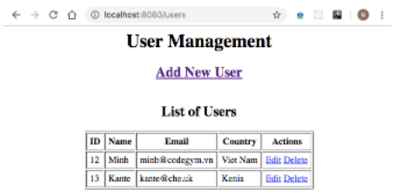
Chúng ta thấy danh sách User đã được hiển thị.
Bước 10: Thêm trang create.jsp, thêm mới User:
<%@ page language="java" contentType="text/html; charset=UTF-8"
pageEncoding="UTF-8" %>
<%@ taglib uri="http://java.sun.com/jsp/jstl/core" prefix="c" %>
<html>
<head>
<title>User Management Application</title>
</head>
<body>
<center>
<h1>User Management</h1>
<h2>
<a href="users?action=users">List All Users</a>
</h2>
</center>
<div align="center">
<form method="post">
<table border="1" cellpadding="5">
<caption>
<h2>Add New User</h2>
</caption>
<tr>
<th>User Name:</th>
<td>
<input type="text" name="name" id="name" size="45"/>
</td>
</tr>
<tr>
<th>User Email:</th>
<td>
<input type="text" name="email" id="email" size="45"/>
</td>
</tr>
<tr>
<th>Country:</th>
<td>
<input type="text" name="country" id="country" size="15"/>
</td>
</tr>
<tr>
<td colspan="2" align="center">
<input type="submit" value="Save"/>
</td>
</tr>
</table>
</form>
</div>
</body>
</html>
Chạy chương trình và test chức năng thêm mới:
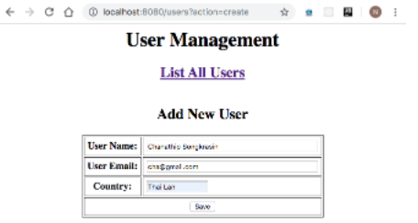
Bước 11: Thêm trang edit.jsp, sửa thông tin User:
<%@ page language="java" contentType="text/html; charset=UTF-8"
pageEncoding="UTF-8" %>
<%@ taglib uri="http://java.sun.com/jsp/jstl/core" prefix="c" %>
<html>
<head>
<title>User Management Application</title>
</head>
<body>
<center>
<h1>User Management</h1>
<h2>
<a href="users?action=users">List All Users</a>
</h2>
</center>
<div align="center">
<form method="post">
<table border="1" cellpadding="5">
<caption>
<h2>
Edit User
</h2>
</caption>
<c:if test="${user != null}">
<input type="hidden" name="id" value="<c:out value='${user.id}' />"/>
</c:if>
<tr>
<th>User Name:</th>
<td>
<input type="text" name="name" size="45"
value="<c:out value='${user.name}' />"
/>
</td>
</tr>
<tr>
<th>User Email:</th>
<td>
<input type="text" name="email" size="45"
value="<c:out value='${user.email}' />"
/>
</td>
</tr>
<tr>
<th>Country:</th>
<td>
<input type="text" name="country" size="15"
value="<c:out value='${user.country}' />"
/>
</td>
</tr>
<tr>
<td colspan="2" align="center">
<input type="submit" value="Save"/>
</td>
</tr>
</table>
</form>
</div>
</body>
</html>
Chạy chương trình và test chức năng sửa đổi:
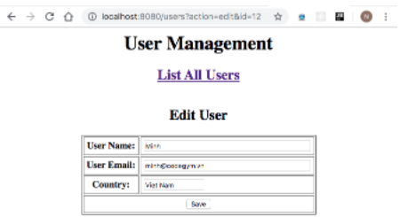
Bước 12: Test chức năng xóa:
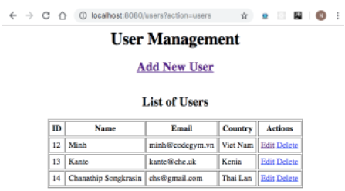
Checkout sang nhánh develop để xem mã nguồn tham khảo: https://github.com/codegym-vn/jwbd-user-manager

